

Established under sub section (3) of Section 1 of Garden City University Act, 2013 (Karnataka Act No. 47 of 2013)

**Dr. A P J Abdul Kalam School of Engineering**

**B.Tech in Computer Science and Engineering (AI &ML, CS,DS)**

PROJECT TITLE: CAB HUB

OVERVIEW: Taxi Services all over india

DESCRIPTION OF THE PROJECT: A taxi, also known as a taxicab or simply a cab, is a type of vehicle for hire with a driver, used by a single passenger or small group of passengers, often for a non-shared ride. A taxicab conveys passengers between locations of their choice. Overall, cab services provide a reliable and efficient transportation option, catering to the needs of individuals, tourists, and business travelers alike.

IMPACT: it will effect all the existing websites because our website gives services all over India, people can book from any corner in India the present websites cannot be booked from all over India but in our website its very easy and less time consuming…….

**PHOTO:** 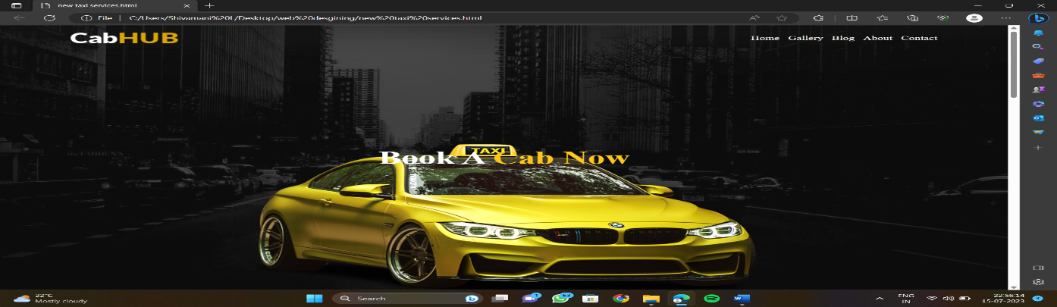

PROJECT TEAM:

L Shivamani (22BTAI115) ph-7483172096

Samkeerth C (22BTAI122)

Shiva Bhagavan S (22BTAI142)

PROJECT GUIDE:

Dr. Indira Devi